1. Install dengan raspberry pi imager (ada di folder)

2. Pilih drive intallasi (ex D), pilih image 2022-01-28-raspios-bullseye-armhf-lite.img

3. setelah selesai copy SSH dan WPA supplicant pada drive Boot

4. ssh ke system, kemudian sudo apt update

5. sudo apt upgrade

6. sudo raspi-config

Advance – Expand file system

Interface Option – Serial – serial shell disable– serial hardware enable – ok

Finish and reboot

7. sudo nano /boot/config.txt

enable_uart=1

core_freq=250

8. sudo reboot

9. ls -l /dev

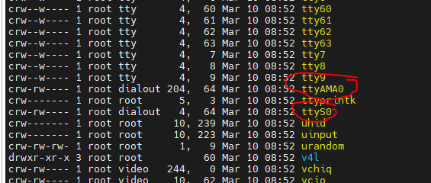\

Pastikan ada 2 serial ini

10. sudo systemctl stop [serial-getty@ttyS0.service](mailto:serial-getty@ttyS0.service)

11. sudo systemctl disable [serial-getty@ttyS0.service](mailto:serial-getty@ttyS0.service)

12. sudo reboot

13. stty -F /dev/ttyS0 38400

14. cat /dev/ttyS0 > ./test.txt (jika data masuk, good to go)